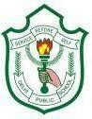
DELHI PUBLIC SCHOOL, HAPUR
Session 2025-26
DPS CODERZ LEAGUE COMPUTER COMPETITION
Class – IV
RESULT DECLARATION

Students’ Name | Class & Section | Position | Winners
Atharv Chaudhary | IV A | I | 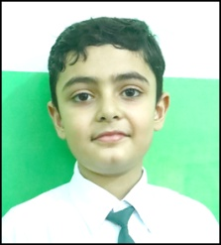  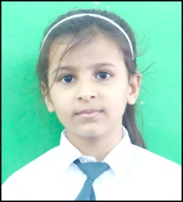
Arnav Dhiman | IV A | II | 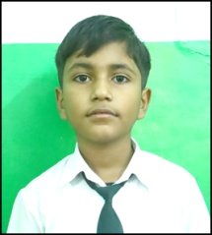
Ayish Anas | IV B | I
Daksh Khanijo | IV B | II | 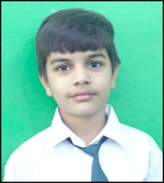
Chetanya Agarwal | IV B | III | 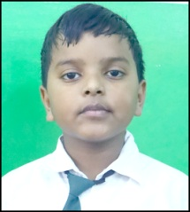
Rewant Chauhan | IV C | I | 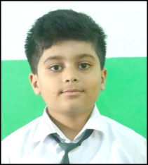
Aishvi Sharma | IV C | II | 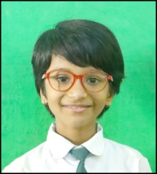

Avni | IV C | III | 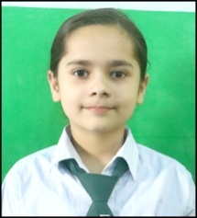  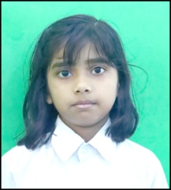
Arin Agarwal | IV D | I | 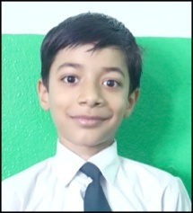
Khyati Agarwal | IV D | I | 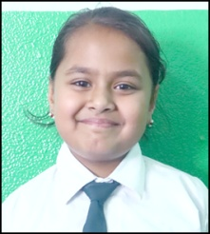
Aarav Sirohi | IV D | II | 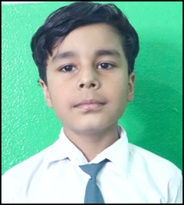
Keshvi Kushwaha | IV E | I

